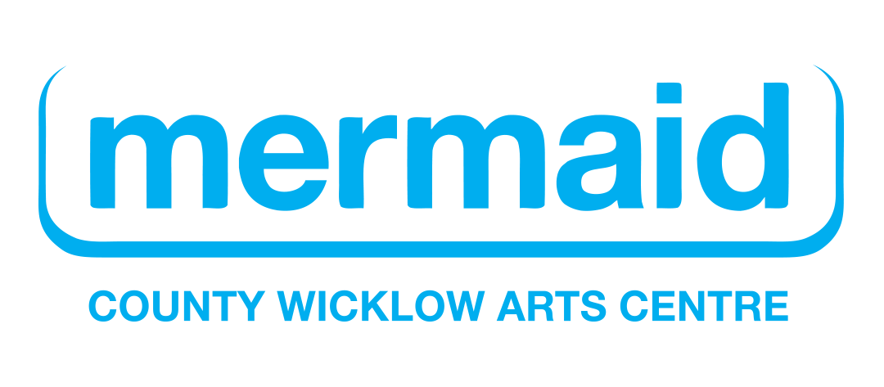
Pay the Artist Policy
Mermaid Arts Centre
Introduction
Mermaid Arts Centre is committed to paying artists fairly, transparently and respectfully for all professional work carried out with us. We recognise the value of artistic work and the time, skills, experience and expertise that artists bring to our programmes, projects and events.
This policy sets out Mermaid Arts Centre’s commitment to fair pay and good working conditions for artists, arts workers and creative practitioners engaged by the organisation.
This policy is informed by the principles of the Arts Council’s Paying the Artist policy and by good practice across the Irish arts sector.
1. Fair Pay
Mermaid Arts Centre will pay artists and arts workers fairly for all professional work undertaken.
This includes:
• performances and presentations;
• rehearsals and development time;
• workshops and facilitation;
• meetings and consultations;
• preparation and research;
• administration connected to projects;
• community engagement activity;
• creative planning and collaboration;
• installation, technical and de-install work where applicable.
Fees will reflect:
• the scope of the work;
• the artist’s experience and expertise;
• the time commitment involved;
• sectoral good practice and current recommended rates.
Mermaid Arts Centre will not expect artists to provide unpaid labour or subsidise projects through their own time or resources.
2. Contracts and Clarity
Artists engaged by Mermaid Arts Centre will receive a written agreement, memorandum of understanding or contract outlining:
• the nature and scope of the work;
• agreed fees and payment schedules;
• timelines and expectations;
• responsibilities of all parties;
• cancellation arrangements where relevant;
• copyright and usage agreements where applicable.
We are committed to communicating clearly and professionally throughout all stages of engagement.
3. Transparency
Mermaid Arts Centre will be open and transparent about artist fees, budgets and available resources.
Where funding is limited, projects will be adapted to match available budgets rather than reducing artist pay below fair and reasonable levels.
We will continue to review our payment practices in line with sector standards and Arts Council guidance.
4. Timely Payment
Mermaid Arts Centre recognises the importance of prompt payment.
We commit to:
• processing artist payments efficiently;
• clearly communicating invoicing requirements;
• paying artists within agreed payment timelines;
• addressing payment queries promptly.
5. Respect and Working Conditions
Mermaid Arts Centre is committed to providing a safe, welcoming and respectful working environment for all artists and arts workers.
Artists engaged by Mermaid Arts Centre will be treated with dignity, professionalism and respect, in line with the Safe to Create Guidelines. Mermaid Arts Centre has fully signed up Safe to Create.
The organisation is committed to equality, diversity and inclusion in its programmes, partnerships and employment practices.
Relevant organisational policies, including dignity at work and safeguarding policies where appropriate, will be shared with artists when relevant to their engagement.
6. Copyright and Credit
Mermaid Arts Centre respects artists’ moral rights and intellectual property.
Artists will be appropriately credited for their work across promotional and programme materials unless otherwise agreed.
Copyright arrangements and future usage rights will be clearly outlined in contracts or agreements.
Where future presentation or commercial benefit arises from work created through a Mermaid Arts Centre partnership, this will be addressed fairly and transparently through contractual agreement.
7. Commitment to Good Practice
Mermaid Arts Centre acknowledges the Arts Council’s Paying the Artist policy and commits to ongoing review of its practices in line with national guidance and sectoral best practice.
We recognise that fair pay is central to sustaining a healthy arts sector and enabling artists to build viable professional careers.
Mermaid Arts Centre will continue to work collaboratively with artists, arts workers and partners to support high-quality artistic practice in an equitable and sustainable way.
Review
This policy will be reviewed biennial by Mermaid Arts Centre to ensure it remains current, effective and aligned with evolving sector standards and organisational practice.

Date Approved by Board: 27th August 2026
Review Date: 25th August 2028

